**BAT BADGE BLINKY-BOT INSTRUCTABLE**

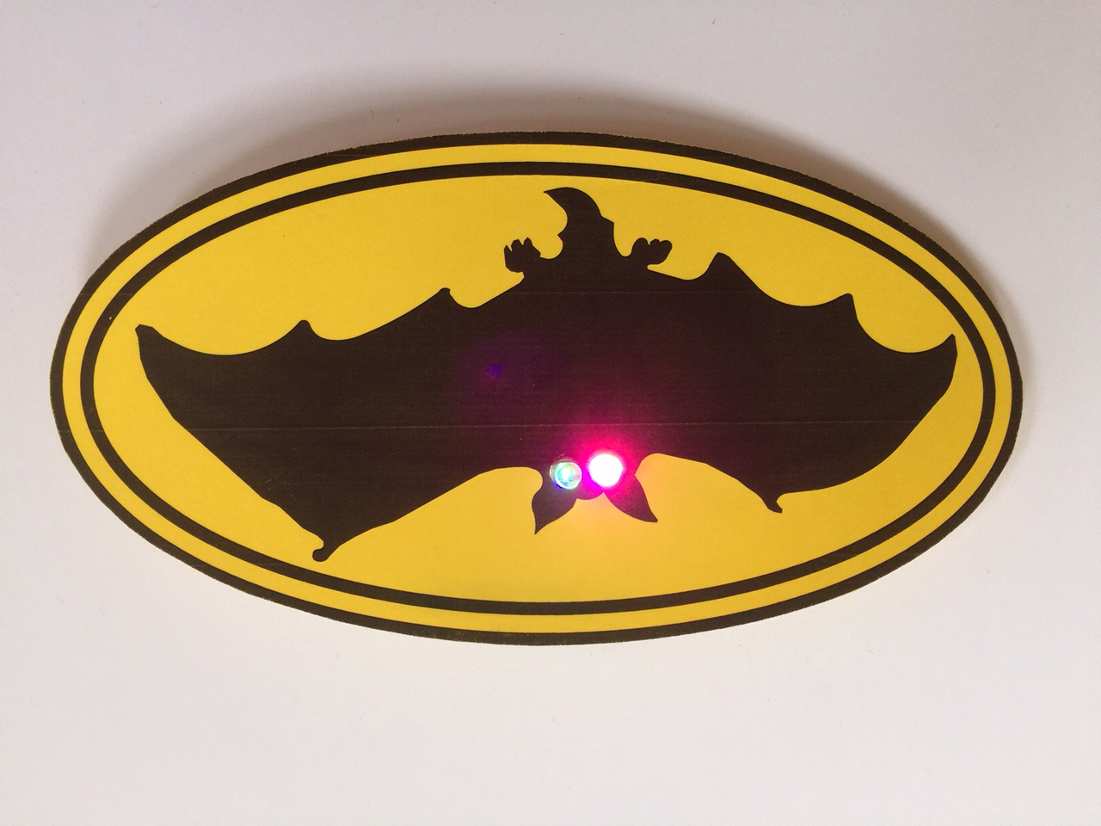

**WESTERN CANADIAN**

**ROBOTICS SOCIETY**

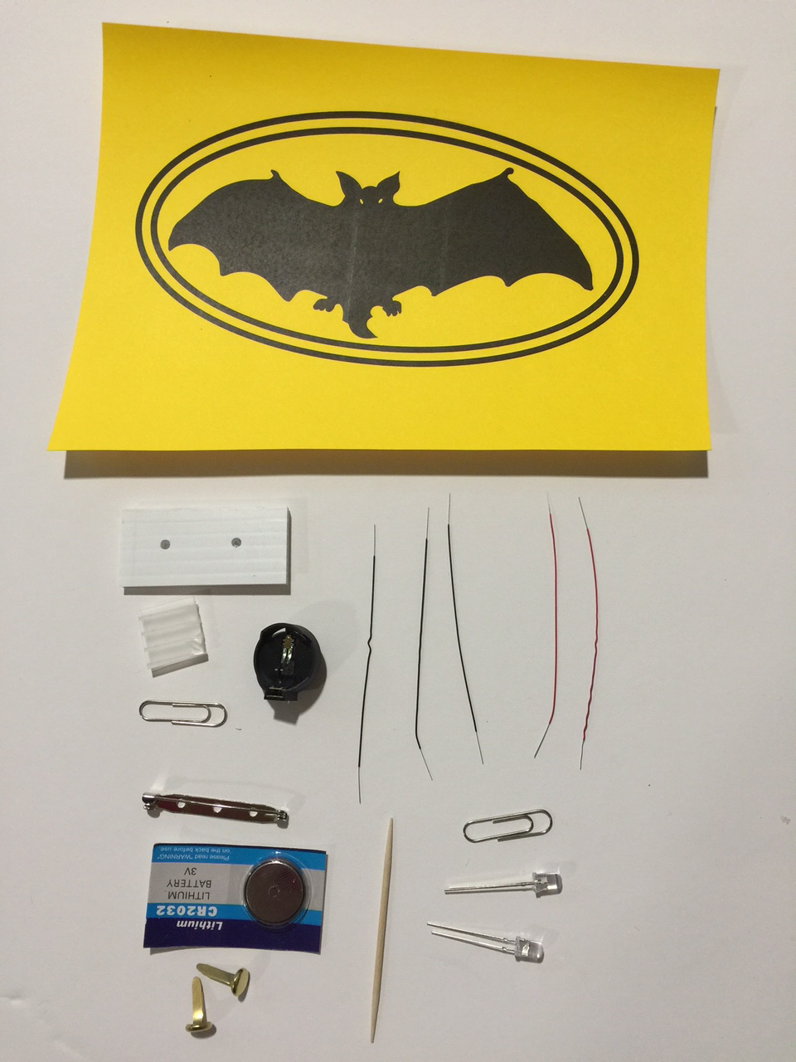

Get the supplies:

1 – bat body printed on black cardstock

3 – 3 inch pieces of black AWG 30 wire (stripped 1/4 - 3/8 inch on both ends)

2 – 3 inch pieces of red AWG 30 wire (stripped 1/4 - 3/8 inch on both ends)

1 – coin cell battery holder

1 – 3V coin cell battery (CR 2032)

2 – fast blink multi-colored LEDs

1 – paper clip

2 – brads (~1/2 inch)

1 – 1 inch x 2 inch corrugated cardboard or plastic piece, with 2 holes punched 1 inch apart

1 – 3/4 x 3/4 inch square corrugated cardboard or plastic piece

1 – pin holder

1 – toothpick

1 – straight pin

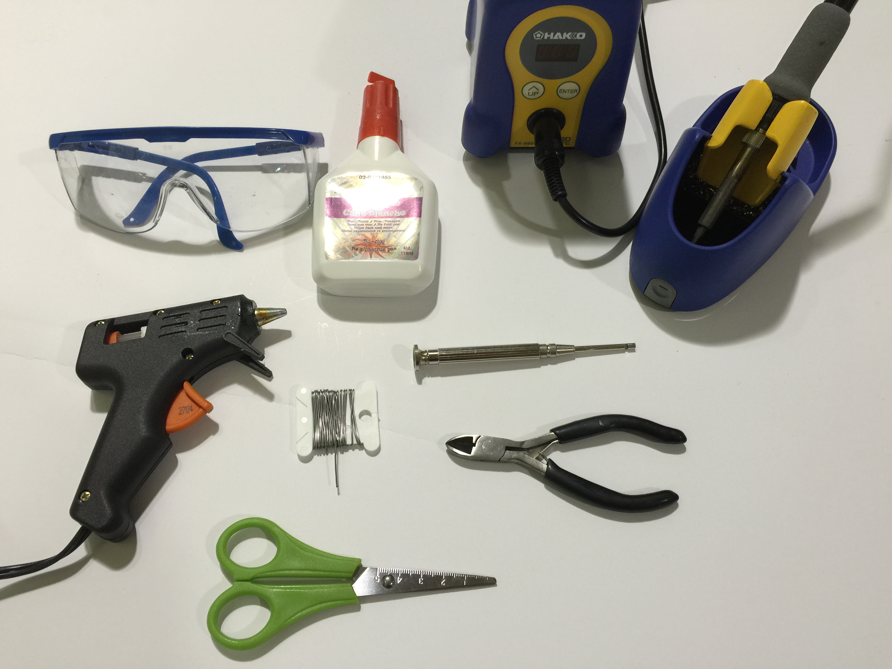

Assemble the tools:

safety glasses

hot glue gun

white glue or glue stick

scissors

wire cutters

wire wrap tool

soldering iron

solder



1. Cut out the oval shape.

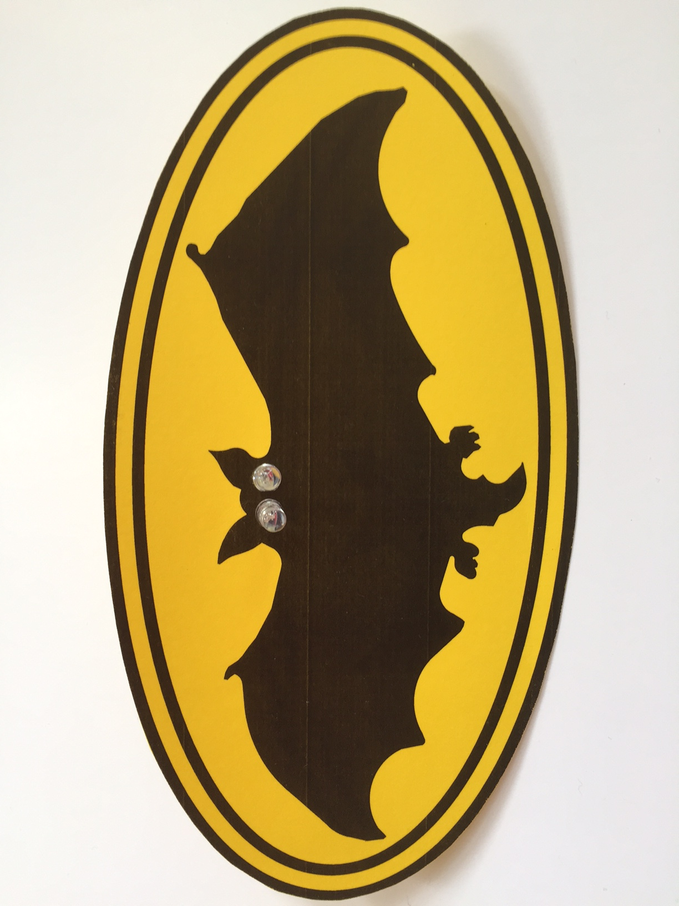

1. Using a straight pin, punch two holes for the LEDs in each of the eyes.
2. Install the LEDs through the holes. Place a small dab of glue under each LED.

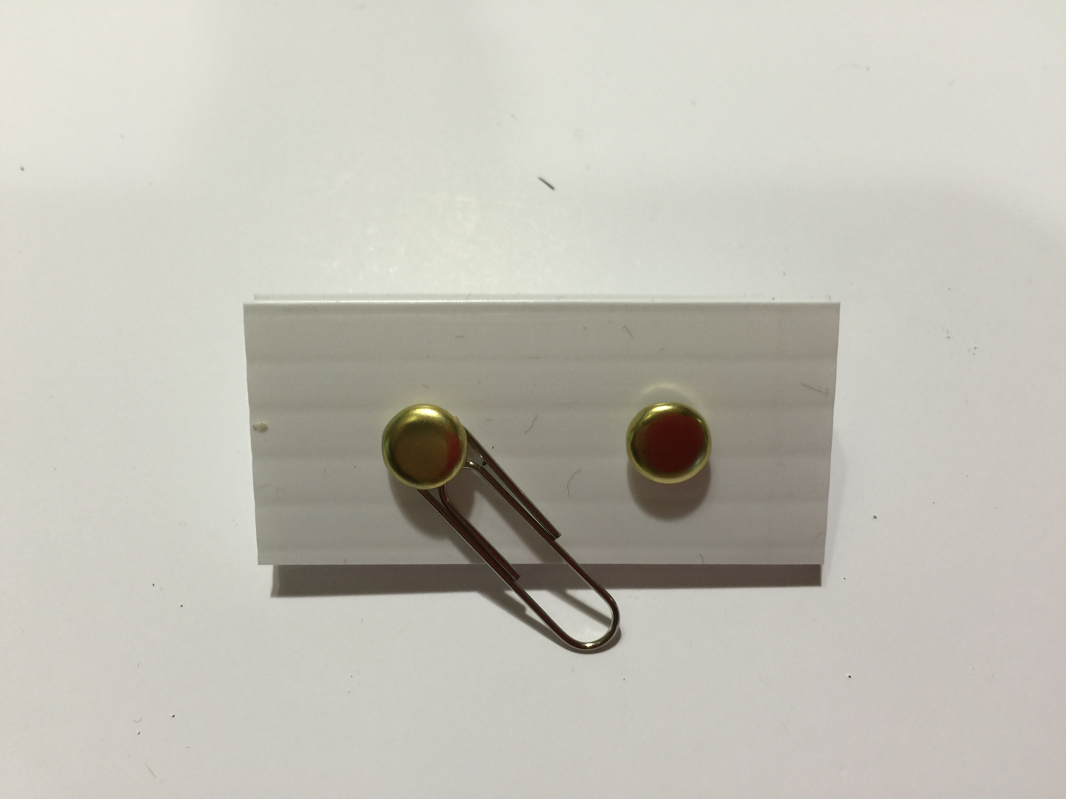

1. Assemble the switch from the corrugated rectangle, the two brads, and the paperclip according to the above picture.

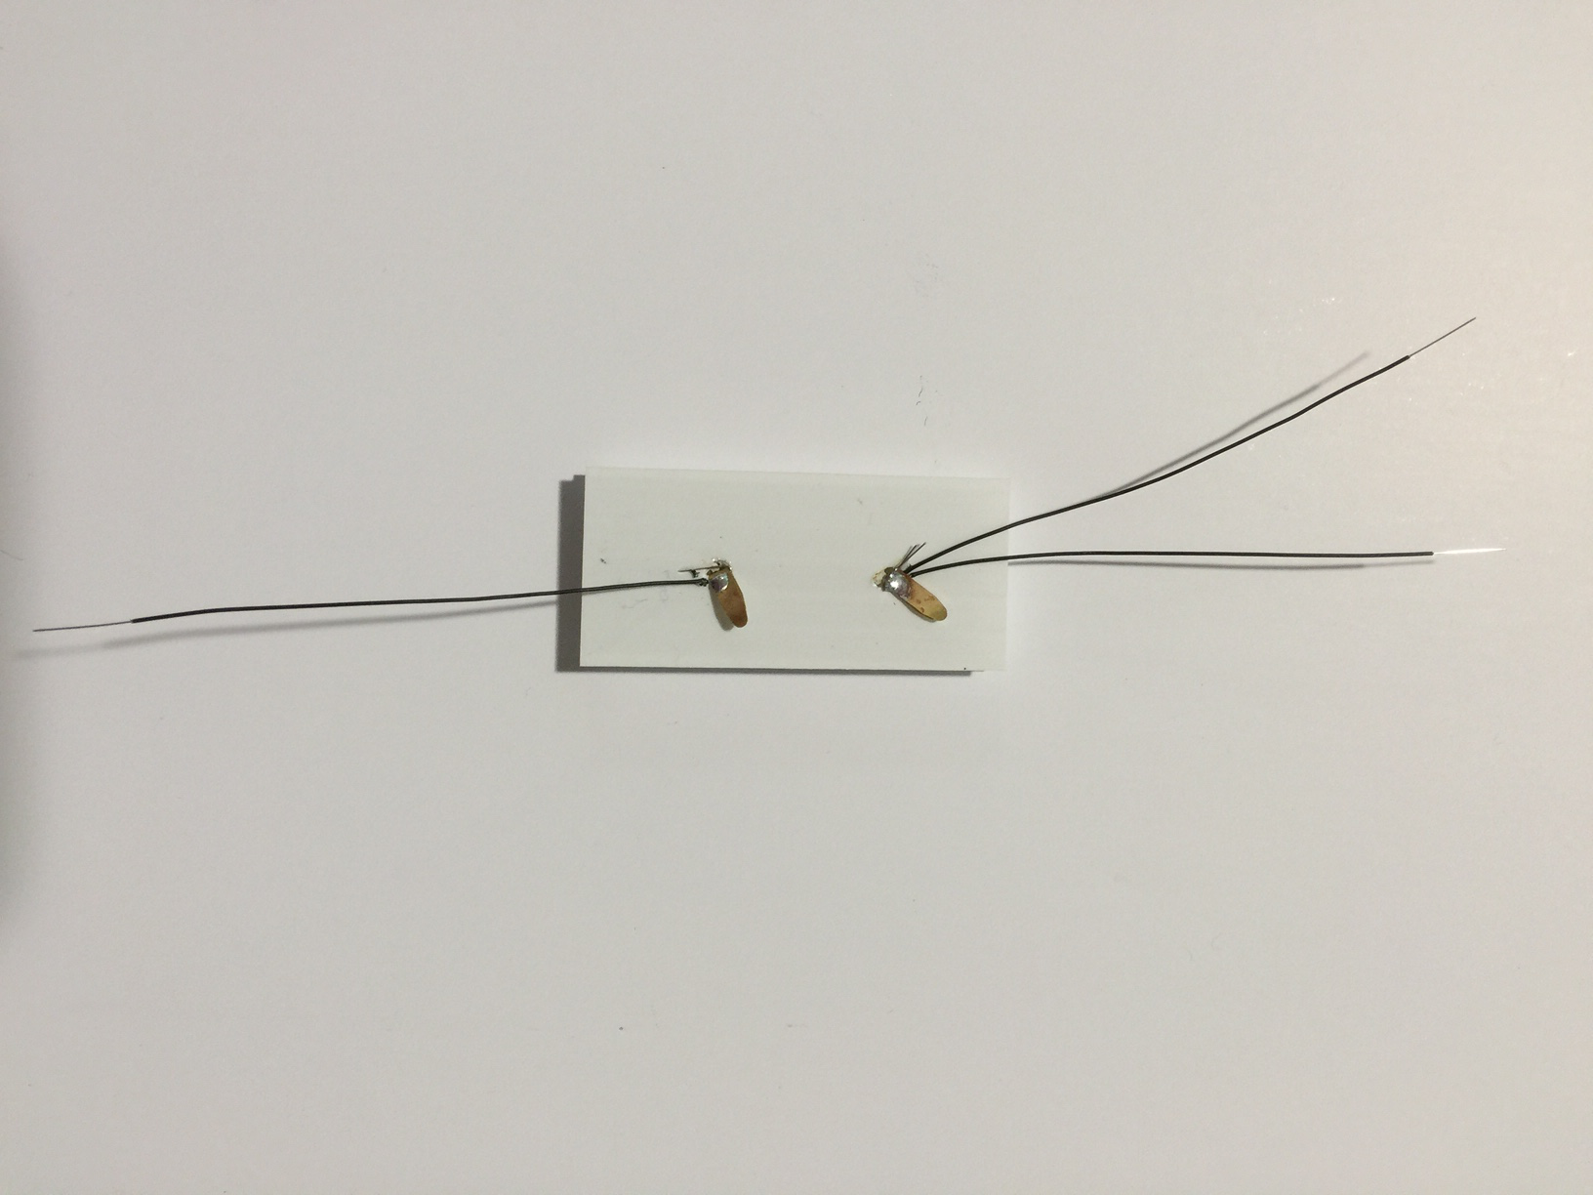

1. On the bottom of the switch, attach two black wires to one brad and one black wire to other brad. Solder in place.

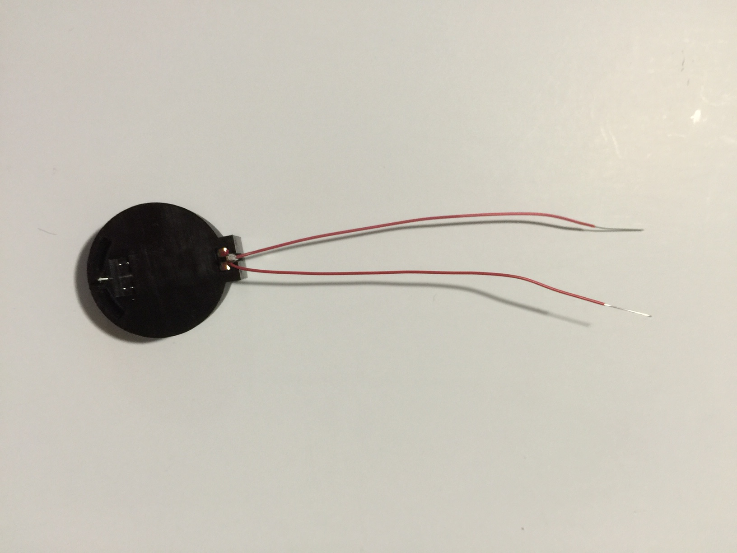

1. Using the wire wrap tool, attach two red wires to positive (larger) end of battery holder. Solder in place.

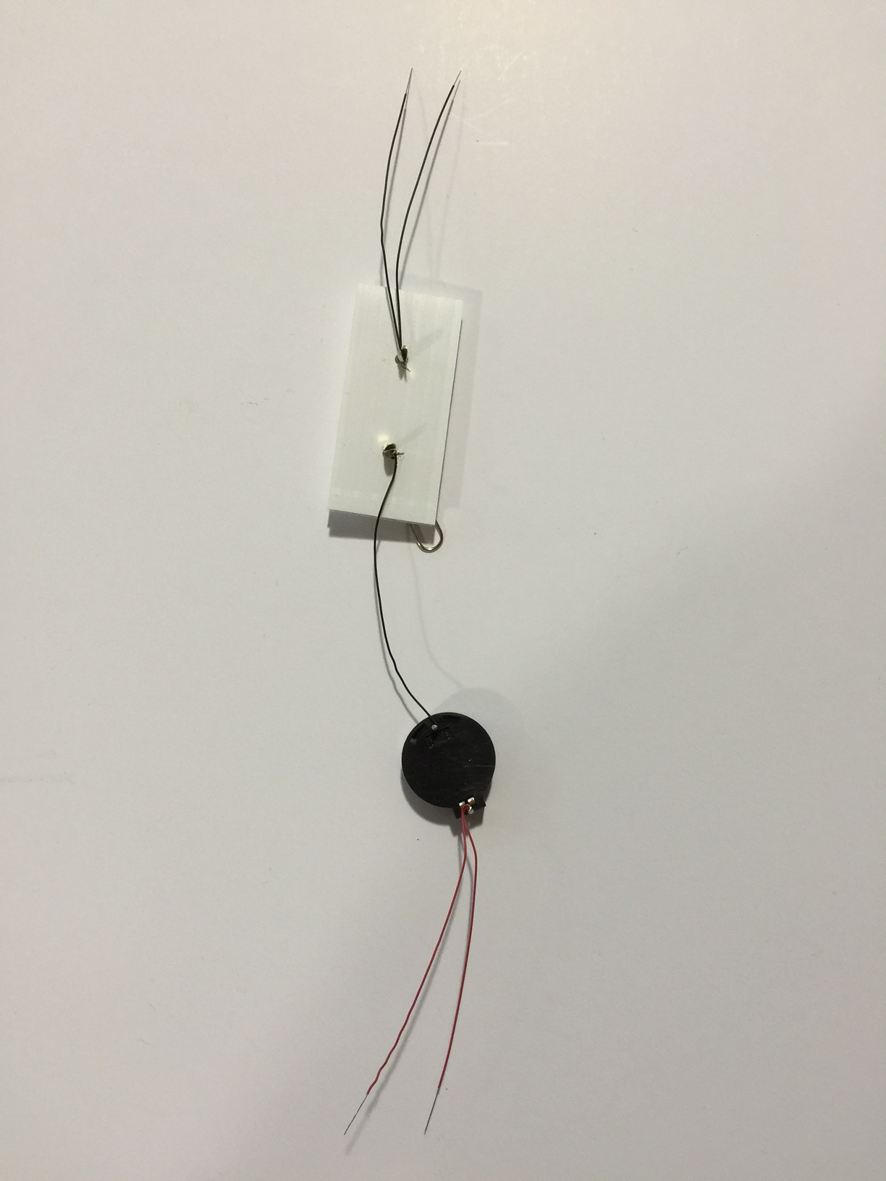

1. Using the wire wrap tool, attach the single black wire from the switch to the negative (smaller) end of the battery holder. Solder in place.

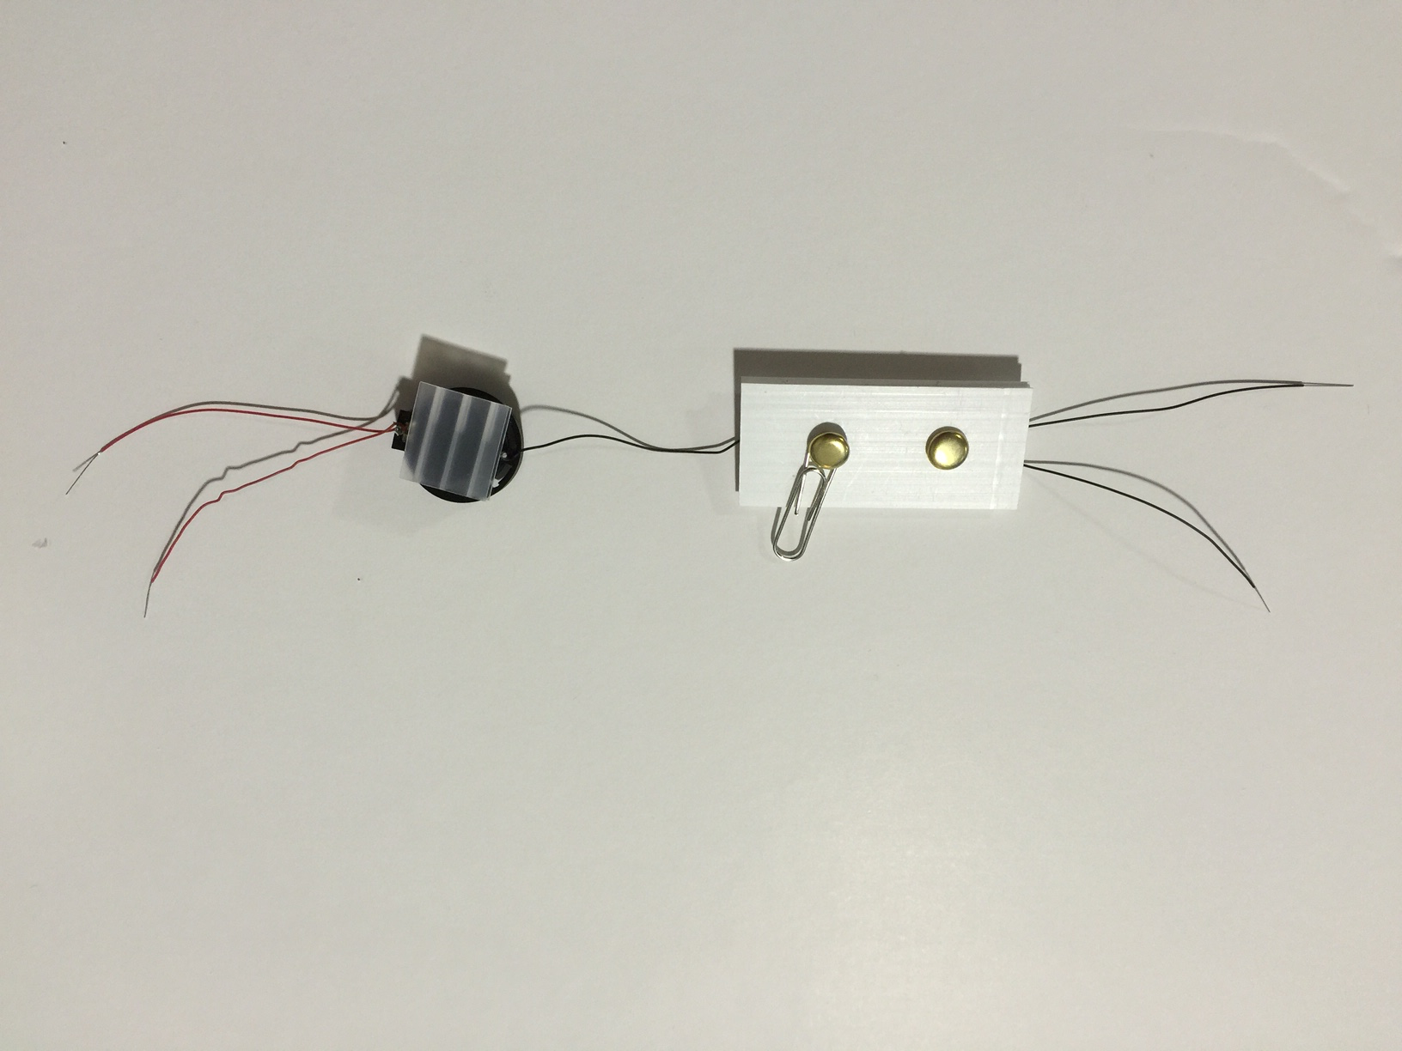

1. Hot glue the small corrugated square to the back of the battery holder.

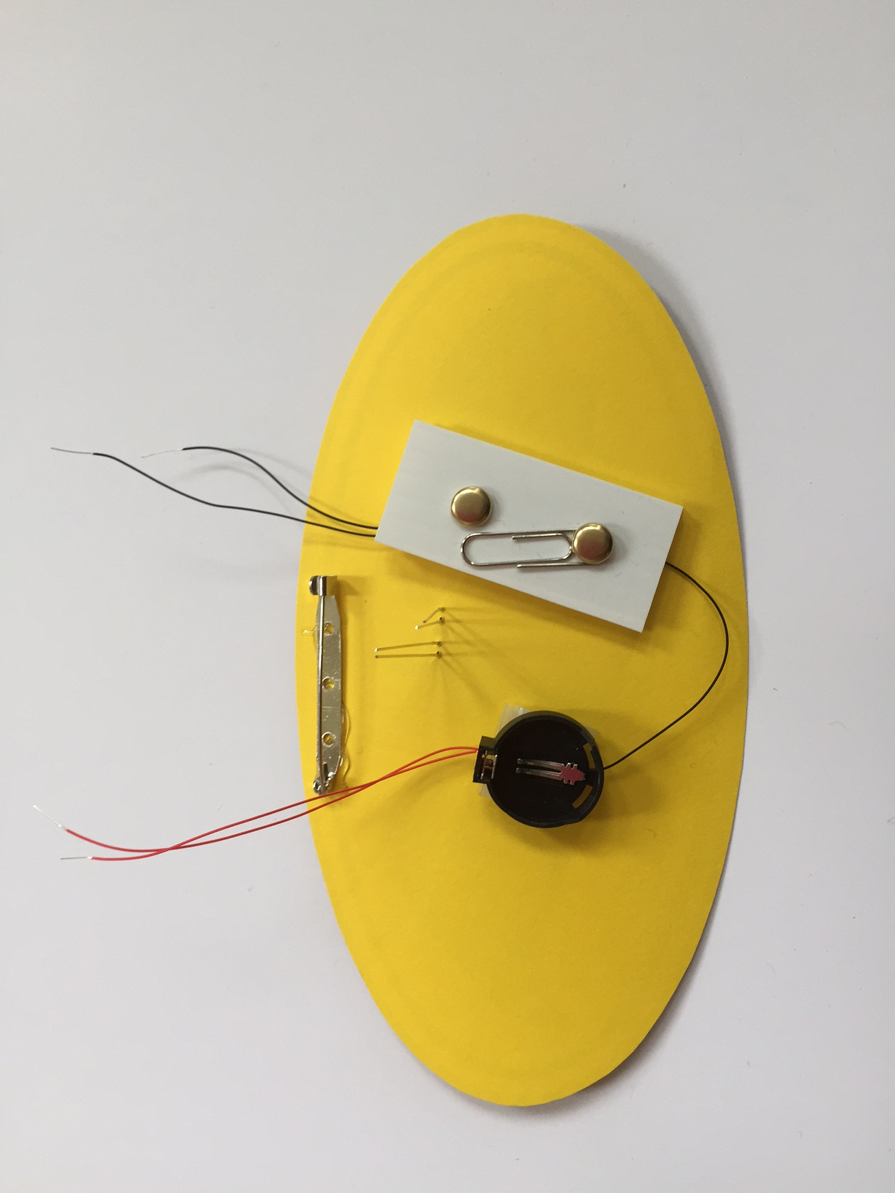

1. Hot glue the bar pin onto the backside of the oval near the top.
2. Hot glue the switch in the center of the oval, making sure that the black wires will reach the LEDs.
3. Hot glue the battery holder in the center of the oval, making sure that the red wires will reach the LEDs.

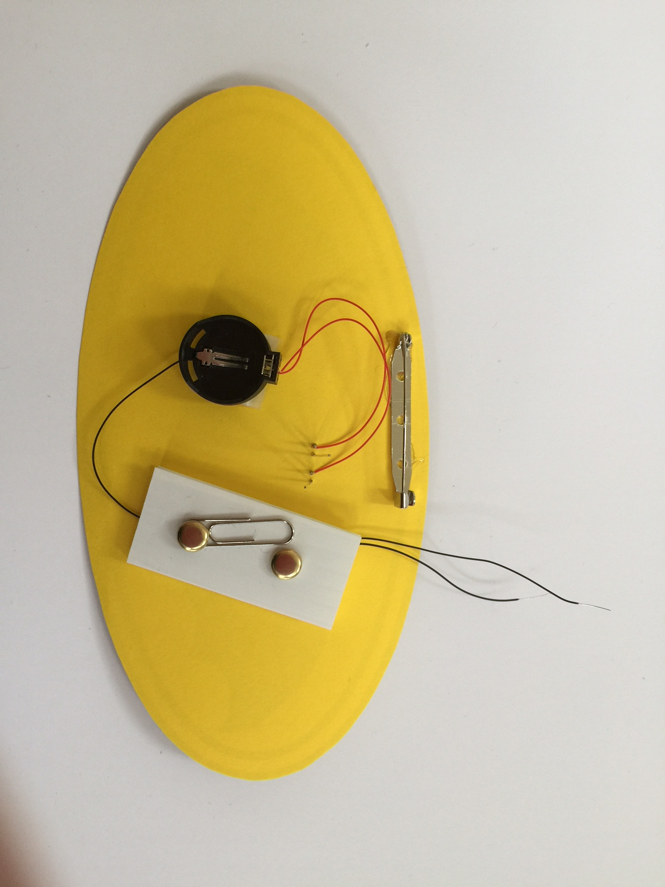

1. After putting on safety glasses, trim the two longer leads of the LEDs to ~1/4 inch.
2. Using the wire wrap tool, attach the two red wires to each of the cut LED leads. Solder in place.

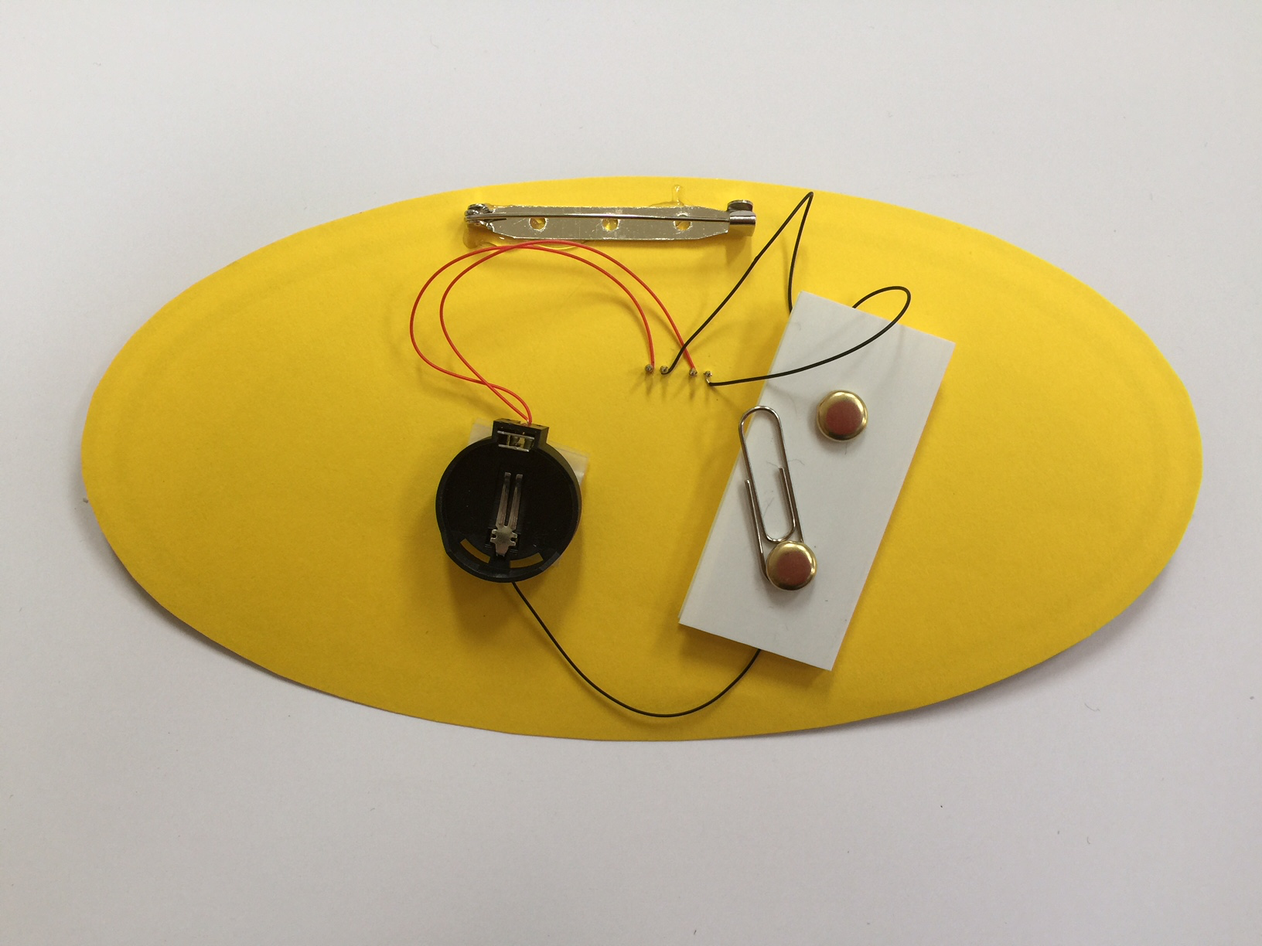

1. After putting on safety glasses, trim the two remaining LED leads to ~1/4 inch.
2. Using the wire wrap tool, attach the two black wires to each of the remaining leads. Solder in place.
3. If needed, put on safety glasses and trim the LED leads again.

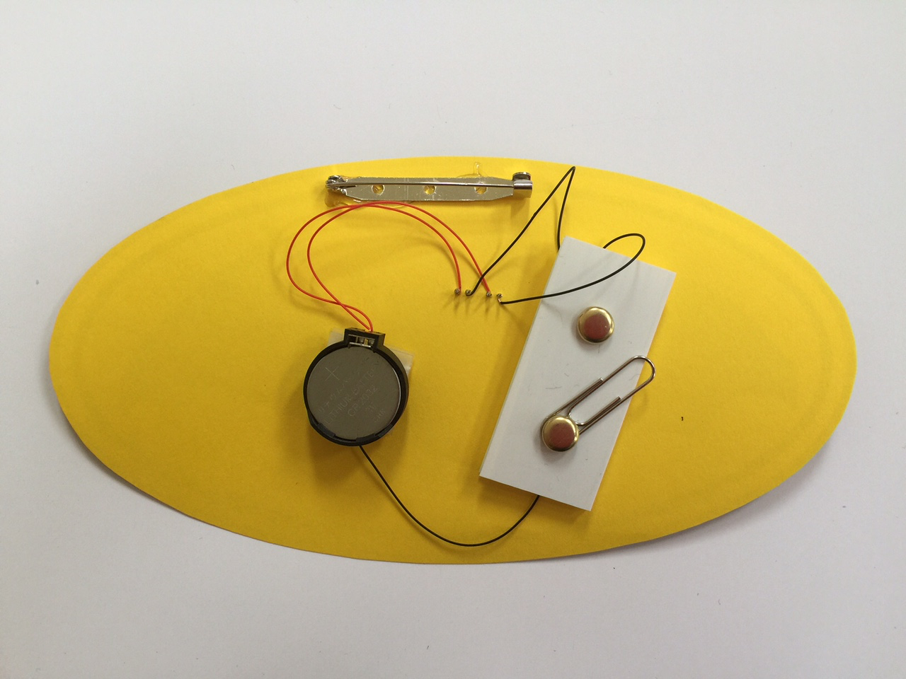

1. Install the battery so that the + side is facing up.



1. Close the paperclip switch and VOILA!

